 | 26.11 Editors - Properties Editor - Visual Effects Properties Tab
Table of content
Detailed table of content 1
Visual Effects 3
General functionality 3
Blur 5
Colorize 6
Flip 6
Glow 7
Pixelate 8
Rim 8
Shadow 9
Swirl 10
Wave Distortion 10

Detailed table of content
Detailed table of content
Detailed table of content 1
Visual Effects 3
General functionality 3
Add 3
Header elements 3
Collapse panel 4
Effect Icon 4
Effect Name 4
Realtime 4
Render 4
Header menu 4
Duplicate 4
Move to first 4
Move to last 4
Remove 5
Change Context 5
Reorder 5
Animate Property 5
Blur 5
Samples 5
Use Depth of Field 5
Size X / Y 5
Rotation 6
Colorize 6
Mode 6
Grayscale 6
Sepia 6
Duotone 6
Transparent 6
Factor 6
Custom 6
Color 6
Factor 6
Flip 6
Axis 7
Glow 7
Mode 7
Luminance 7
Color 7
Glow Color 7
Blend Mode 7
Opacity 7
Size X / Y 7
Rotation 7
Samples 8
Glow Under 8
Pixelate 8
Size X / Y 8
Antialiasing 8
Rim 8
Rim Color 8
Mask Color 8
Blend Mode 8
Offset X / Y 8
Blur subpanel 9
Blur X / Y 9
Samples 9
Shadow 9
Shadow Color 9
Offset X / Y 9
Scale X / Y 9
Rotation 9
Object Pivot 9
Blur subpanel 9
Blur X / Y 9
Samples 9
Wave Effect subpanel 10
Orientation 10
Amplitude 10
Period 10
Phase 10
Swirl 10
Object 10
Radius 10
Angle 10
Wave Distortion 10
Orientation 10
Amplitude 11
Period 11
Phase 11

Visual Effects

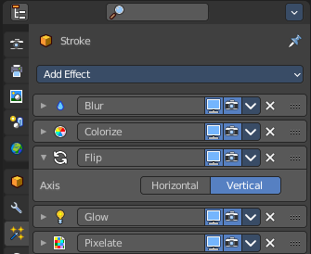
Visual Effects are for the Grease Pencil object only.
In the viewport you can apply so called visual effects to Grease pencil strokes. Like a pixelate effect.
The effect is applied to the whole image in the viewport. But just to the grease pencil object that has the effect applied. Other grease pencil objects will not be affected.
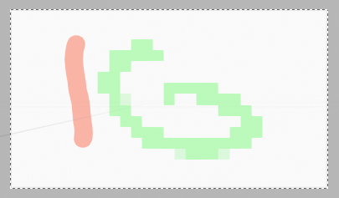
The effects renders to file. But visual effects are mainly meant for preview purposes, to judge how the result could look like after compositing. The compositing nodes are more accurate.
Visual Effects works with all renderers. Cycles, Workbench and Eevee.

You need to be in the viewport shading mode rendered. The effect does not show in material preview mode.
The effects are dependant of zoom and orientation of the viewport camera.

General functionality

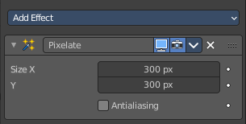
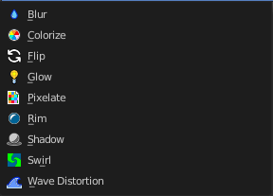
Add

To add an effect to a grease pencil object, simply open the drop down menu, and choose the type of modifier that you want to add.
This will add the effect to the list.

Header elements
You might want to remove an effect. Or just see the effect in the final rendering. This can be adjusted in the header. The header is what you see when you collapse the effects panel.
Elements are explained from left to right.

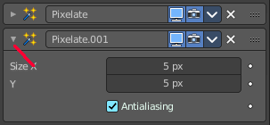
Collapse panel
The whole modifier panel can be collapsed. Click at the arrow button up left in the header.

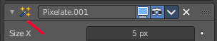
Effect Icon
This icon shows the type of the effect. And has no further functionality.

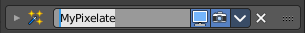
Effect Name
The name of the modifier. You can rename effects by clicking into the edit field and change the text.

Realtime
Display the modifier in the viewport.

Render
Display the modifier in the rendered result.

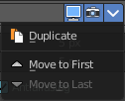
Header menu

Duplicate
Duplicates the modifier, and places the duplicate below the current modifier.

Move to first
Move the modifier to the first position in the stack.

Move to last
Move the modifier to the last position in the stack.

Remove
Removes the modifier from the stack.

Change Context
Some modifiers cannot be removed from the modifiers stack directly. Like fluid modifiers. You need to remove the fluid simulation instead, in the physics tab. With the change context button you jump to the required tab where you can now remove the simulation.

Reorder
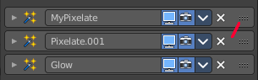
You can have more than one modifier in the list. And sometimes the order of the modifiers is very important.
Grab the handler at the right and drag the modifier to the position where you want it to have.

Animate Property
Some of the properties can be animated. Click at the animate property button at the right to add a keyframe.

Blur

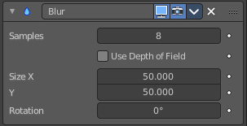
Applies a Gaussian blur to the object.

Samples
Number of Blur samples (0 disabled the blur effect).

Use Depth of Field
When enabled, the blur effect uses the focal plane distance of the actual camera to simulate a depth of field effect. Only available in camera view.

Size X / Y
The blur factor in x and y direction

Rotation
Rotation of the effect.

Colorize

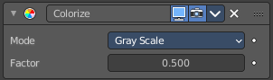
Applies colorizing effects to the object.

Mode

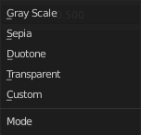
Grayscale
Converts to a grayscale image.

Sepia
Converts to a sepia tone image.

Duotone
Converts to a black and white posterize image with high contrast and brightness.

Transparent
Add color transparency.

Factor
Controls the mix value (0 fully transparent, 1 fully opaque).

Custom
Allows to define a tint custom color.

Color
Sets the tint color.

Factor
How strong the effect is applied.

Flip

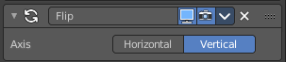
Shows the object flipped horizontally and/or vertically.

Axis
The axis to use for the flipping.

Glow

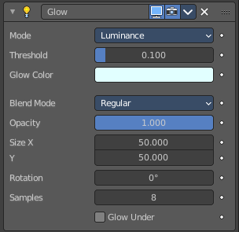
Adds a glowing rim around the object.

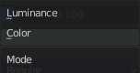
Mode
The mode of the glow effect.

Luminance
The glow light illuminates the entire object.

Color
The glow light only affect a single color.

Glow Color
Defines the glow color.

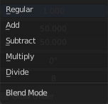
Blend Mode
How to blend the glow with the image.

Opacity

Size X / Y
The size of the effect.

Rotation
Rotation of the effect.

Samples
Number of blur samples.

Glow Under
Glow only affects alpha areas. Does not work with the blend mode Regular.

Pixelate

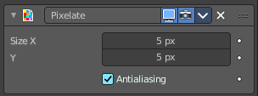
Pixelates the grease pencil stroke.

Size X / Y
The size of the pixels.

Antialiasing
Use antialiasing.

Rim

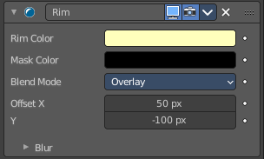
Shows a simulated rim light on the object contour.
For simulating the rim light, a masked color silhouette of the object is displaced in horizontal and/or vertical direction.

Rim Color
The color of the rim light.

Mask Color
Defines a color to keep unaltered.

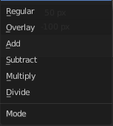
Blend Mode
How to blend the rimlight with the image.

Offset X / Y
Color mask displacement in pixels along the X and Y axis.

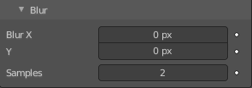
Blur subpanel

Blur X / Y
The blur scale in pixels on the X and Y axis.

Samples
Number of blur samples. A value of 0 disables the blur effect.

Shadow

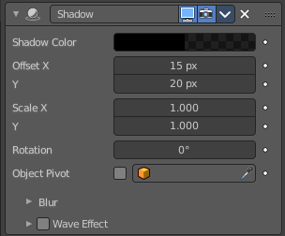
Shows a simulated shadow casted by the object.

Shadow Color
Defines the shadow color.

Offset X / Y
The shadow displacement in pixels along the X and Z axis.

Scale X / Y
Scales the size of the shadow along the X and y axis.

Rotation
The shadow rotation around the Grease Pencil object. You can use the center of the grease pencil object. With Object Pivot enabled you can also choose the pivot of another object.

Object Pivot
Use the pivot of another object for rotation. You need to pick another object from the scene.

Blur subpanel

Blur X / Y
The blur scale in pixels on the X and Y axis.

Samples
Number of blur samples. A value of 0 disables the blur effect.

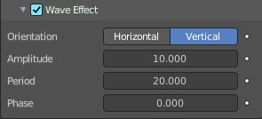
Wave Effect subpanel
Apply a wave distortion to the shadow.

Orientation
Sets a horizontal or vertical direction for the waves.

Amplitude
Controls the strength and the depth of the wave.

Period
Controls the wave period. The time it takes to complete one cycle.

Phase
Shifts the wave pattern over the shadow.

Swirl

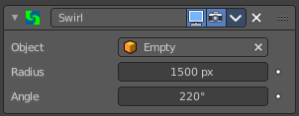
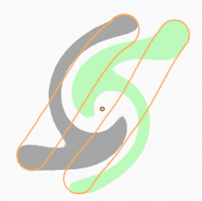
Applies a swirling pattern to the grease pencil object. The effect uses another object as the center of the swirl. An empty for example.

Object
Pick the object that you want to use as the center of the swirl.

Radius
External radius size of the swirl. The needed radius depends of camera zoom.

Angle
Rotation angle of the swirl. A value of 0 shows no swirl.

Wave Distortion

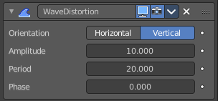
Adds a wave distortion to the grease pencil object.

Orientation
Sets a horizontal or vertical direction for the waves.

Amplitude
Controls the strength and the depth of the wave.

Period
Controls the wave period. The time it takes to complete one cycle.

Phase
Shifts the wave pattern over the grease pencil object.

